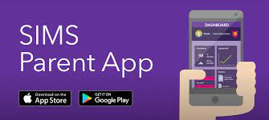
Easy access to important school information. We have a convenient new way to share information with you about your child’s school life. You can access the system from a smartphone, tablet or PC – anytime, anywhere.

What will you find in the SIMS Parent app:
· Important information such as attendance, behaviour, achievement and homework
· School term, inset dates and contact details available at the click of a button
· Access your child’s school report
· Receive notifications to remind you about important information such as key dates for your diary
· Access to update your contact details, so we always have the most up-to-date information in case of emergency
· If you have more than one child at school, you’ll have access to information for all your children, from the same app. The information that you receive through the app will help you to stay up-to-date with your child’s school life as well as support your child’s development and progress.

Getting started with the SIMS Parent app
1. We will send you an activation email, simply click on the link from your tablet, PC or smartphone to activate your account.
2. You can then login using your normal Facebook, Twitter, Google or Microsoft username and password.
3. From your smartphone or tablet, download the app from the Google Play or Apple App store - search for SIMS Parent. 4. From a PC or Windows phone, login online at www.sims-parent.co.uk Please note that your activation email is unique to you and should not be used by anyone else. If you require an additional login then please contact your school. Your activation email will expire after 14 days if it is not used, please contact your school if you require a replacement after this date.

Having Issues?
In the first instance, please contact the academy to make sure we have the current email address. If there is still an issue, please contact your child’s year team.

